**Project for Database Design:**

# Phase II. Relational Schema

|  |  |
| --- | --- |
| Kinjal Basu | Piyush Mahatkar |
| [kxb170730@utdallas.edu](mailto:kxb170730@utdallas.edu) | [pkm170230@utdallas.edu](mailto:pkm170230@utdallas.edu) |
|  |  |

(Week 6-10: Feb.19-Mar.26)

1. Modified EER diagram:
2. Mapping Relational Schemas

**2.1** **For each regular entity type in the EER Diagram,** we created a relation that includes all the simple attributes. We Included only the simple component attributes of a composite attribute. We chose one of the key attributes as the primary key.

In our EER Diagram, Organization_Event_ Payment_Details , Event, Organization_Event_ Bill_Details, language, Hotel_rooms, Payment, Individual_Customer _Bill_Details , and Language are the Regular entities.

For Specialization we have used the strategy of using all the attributes for sub classes and super classes. Our EER Diagram has specializations and unions. Employee Entity is specialized to accountant, management, Tech support, housekeeping and conceige, Dining staff and Receptionist. Customer is specialized to Organizational client and individual customer. We have also created a Event_staff entity as a Union for Management, Tech_Support, Dining staff and accountant.

**Specialization:**

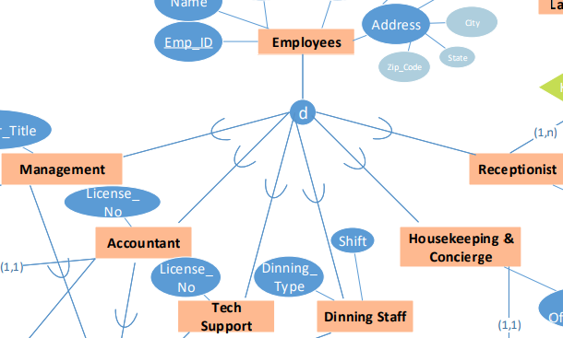

Union:

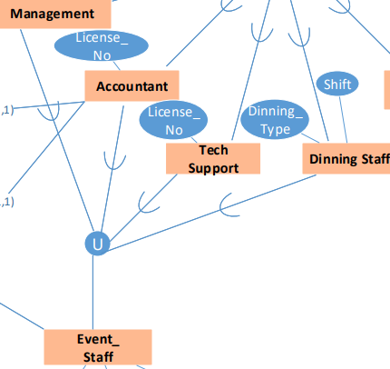

* 1. **Mapping of Weak Entity Types:**

For each weak entity type in the ER schema with owner entity type, we create a relation and include all simple attributes as attributes. In addition, include as foreign key attributes, the primary key attribute(s) of the relation that correspond to the owner entity type; this takes care of mapping the identifying relationship type. The primary key here is the combination of the primary key(s) of the owner(s) and the partial key of the weak entity type.

We have Direct_bill_account (foreign key with organizational_customer_id) and Customers_activity (foreign key as Individual_customer_Id) as week entities.

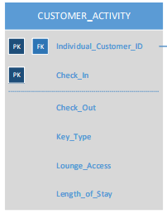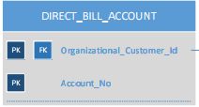

* 1. Mapping of Binary 1:1 Relationship Types

As an example, Mapping to Binary 1:1 Relationship between Housekeeping and Hotel_Rooms.

|  |  |
| --- | --- |
| Relation | Mapping Method |
|  | Since it is a one to one relationship, we use the foreign key approach. Since on Hotel_Rooms side, the relationship is total participation, we include housekeeping_id as a foreign key in Hotel_Rooms |

* 1. Mapping of Binary 1:N Relationship Types

Similar mapping of 1:N occurs in Accountant and Event.

|  |  |
| --- | --- |
| Relation | Mapping Method |
|  | Since it is a one to many relationship, The N-side of this relationship type is Event. Thus we include the primary key Accountant_Id of the relation Accountant as foreign key in relation Event. |

* 1. Mapping of Binary M:N Relationship Types

Here there is a M:N relationship between Individual_Client and Hotel_Rooms. This mapping is done using a separate relation table which has a foreign key from both the entities. Hence this new table is named as Booking_Details.

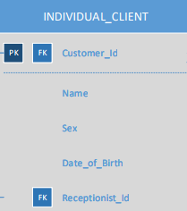 m 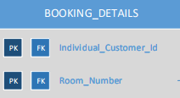 n 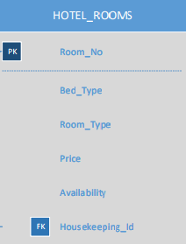

* 1. Mapping of Multi-valued Attributes

We are creating a new entity for multivalued attributes, with primary key of referring relation as the foreign key in the new relation.

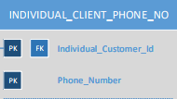 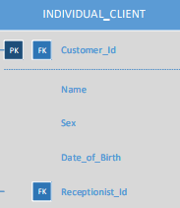

* 1. Mapping of N-ary Relationship Types

There are no n-ary relationships used in the design.

**2.8 Final Relational Schema.**

1. Documentation for schemas

3.1 Explanation for format design

Rules and assumptions:

* Employee_ID is a 9-Digit Number.
* Years_of _experience for housekeeping_staff is range(0-50)
* Individual_Customer id is a 6 digit number.
* Phone number for customer is a 10 digit number of format (xxx)xxx-xxxx
* Date_of_Birth format is MM/DD/YYYY
* Room number is a 4 digit number.
* check-in date (‘MM/DD/YYYY’) + time (‘HH-MM-SS’)
* key type has one of the two values (card key or digital key),
* lounge access has one of the two values (Yes/No)
* organization client is uniquely identified by an ID (6-digit number)
* Every event staff member is assigned on-call number (4-digit number)
* Each event has an event ID (4-digit number).
* Each bill has a unique ID (6-digit number), with date issued format (‘MM/DD/YYYY’) and total amount in numbers.

3.2 Format for Every Relation

|  |  |
| --- | --- |
| **Customer Activity:** | Data Type |
| Individual_Customer_ID  Check_In  Check_Out  Key_Type  Lounge_Access  Length_of_Stay | Integer (6 digit)  MM/DD/YYYY  MM/DD/YYYY  Boolean (Card(0)/Digital(1))  Boolean(Yes/No)  Integer |

|  |  |
| --- | --- |
| **CUSTOMER:** | Data Type |
| Customer_Id | Integer (6 digit) |

|  |  |
| --- | --- |
| **ORGANIZATION_EVENT_PAY_DETAILS** | Data Type |
| Payment_Id  Payment_Mode  Amount  Date  Time  Org_Cust_Id | Integer  String <chars(20)>  Integer  MM/DD/YYYY  HH:MM:SS  Integer (6 digit) |

|  |  |
| --- | --- |
| **DIRECT_BILL_ACCOUNT** | Data Type |
| Organizational_Customer_Id  Account_No | Integer (6 digit)  Integer |

|  |  |
| --- | --- |
| **PAYMENT_THROUGH_DETAILS** | Data Type |
| Payment_Id  Bill_Id | Integer  Integer(6 Digit) |

|  |  |
| --- | --- |
| **ORGANIZATION_EVENT_BILL_DETAILs** | Data Type |
| BILL_Id  Amount  Bill_Date  Accountant_ID  Event_ID | Integer (6 digit)  Integer  MM/DD/YYYY  Integer  Integer (4 digit) |

|  |  |
| --- | --- |
| **ORGANIZATIONAL_CLIENT** | Data Type |
| Customer_Id | Integer (6 digit) |

|  |  |
| --- | --- |
| **INDIVIDUAL_CLIENT** | Data Type |
| Customer_Id  Name  Sex  Date_of_Birth  Receptionist_Id | Integer (6 digit)  String (20 Chars)  M/F  MM/DD/YYYY  Integer |

|  |  |
| --- | --- |
| **EVENT_HOST** | Data Type |
| Event_Id  Organizational_Client_Id | Integer (4 digit)  Integer (6 digit) |

|  |  |
| --- | --- |
| **MANAGEMENT** | Data Type |
| Employee_Id  Manager_Title  Event_Staff_Id | Integer (9 digit)  String (20 chars)  Integer |

|  |  |
| --- | --- |
| ACCOUNTANT | Data type |
| Employee_Id  License_No  Event_Staff_Id | Integer (9 digit)  Integer  Integer |

|  |  |
| --- | --- |
| **TECH_SUPPORT** | Data Type |
| Employee_Id  License_No  Event_Staff_Id | Integer (9 digit)  Integer  Integer |

|  |  |
| --- | --- |
| **DINNING_STAFF** | Data Type |
| Employee_Id  Shift  Dining_Type  Event_Staff_Id | Integer (9 digit)  string  string  Integer |

|  |  |
| --- | --- |
| **HOUSEKEEPING_CONCIERGE** | Data Type |
| Employee_Id  Year_of_Experience | Integer (9 digit)  Integer (range (0-50)) |

|  |  |
| --- | --- |
| **RECEPTIONIST** | Data Type |
| Employee_Id  Year_of_Experience | Integer (9 digit)  Integer (range (0-50)) |

|  |  |
| --- | --- |
| **EMPLOYEE** | Data Type |
| Employee_Id  Name  Age  Salary  Street_No  Street_Name  City  State  Zip | Integer (9 digit)  String  Integer  Integer  Integer  String  String  String  Integer |

|  |  |
| --- | --- |
| **EVENT** | Data Type |
| Event_Id  Time  Date  Deposite  Manager_Id  Accoutant_Id | Integer (4 digit)  HH:MM:SS  MM/DD/YYYY  Integer  Integer  Integer |

|  |  |
| --- | --- |
| **EVENT_STAFF** | Data Type |
| Event_Staff_Id  On_Call_Number  On_Call_Speaker_Number | Integer  Integer (4 digit)  Integer |

|  |  |
| --- | --- |
| **EVENT_ORGANIZED_BY** | Data Type |
| Event_Id  Event_Staff_Id | Integer (4 digit)  Integer |

|  |  |
| --- | --- |
| **INDIVIDUAL_CUSTOMER_BILL_DETAILS** | Data Type |
| Bill_Id  Bill_Amount  Customer_Id | Integer (6 digit)  Integer  Integer (6 digit) |

|  |  |
| --- | --- |
| **INDIVIDUAL_CLIENT_PHONE_NO** | Data Type |
| Individual_Customer_Id  Phone_Number | Integer (6 digit)  Integer (10 digit) |

|  |  |
| --- | --- |
| **PAYMENT** | Data Type |
| Payment_Id  Payment_Date  Payment_Time  Bill_Id  Individual_Customer_Id | Integer  MM/DD/YYYY  HH:MM:SS  Integer (6 digit)  Integer (6 digit) |

|  |  |
| --- | --- |
| **BOOKING_DETAILS** | Data Type |
| Individual_Customer_Id  Room_Number | Integer (6 digit)  Integer (4 digit) |

|  |  |
| --- | --- |
| **INDIVIDUAL_CLIENT_REWARD_MEMBER_NO** | Data Type |
| Individual_Customer_Id  Member_No | Integer (6 digit)  Integer |

|  |  |
| --- | --- |
| **HOTEL_ROOMS** | Data Type |
| Room_No  Bed_Type  Room_Type  Price  Availability  Housekeeping_Id | Integer (4 digit)  String  String  Integer  Boolean  Integer |

|  |  |
| --- | --- |
| **ACCOUNTANT** | Data Type |
| Employee_Id  License_No  Event_Staff_Id | Integer (9 digit)  Integer  Integer |